Instructions for coaches:
- Register for a Human Kinetics Coach Education account at: https://coacheducation.humankinetics.com/account/register.
  - You MUST use your pcsb.org email address when creating your account.
  - Select Florida School Districts as your organization
  - Select Pinellas County School District (FL) as your sub org
- After your account is created and/or you are logged into your account, visit this link: https://coacheducation.humankinetics.com/discount/PCSBFL?redirect=%2Fcollections%2F8050.
- Add all three required courses to your cart:
  - Coaching Principles, Fifth Edition;
  - Sport First Aid, Fifth Edition; and
  - Select the course for the Sport that you coach (exception is Bowling, choose any of the sport-specific courses)
- Go to your cart (top right corner of your screen) and click CHECK OUT.
- A discount should auto-apply to your cart bringing your total to $0.00. If this is not the case, enter PCSBFL in the discount code box (right side of your screen) and hit APPLY.
- Add your address (you will not need to add payment information) and click Complete order.
- You will receive an order confirmation on screen and via email. You’ll also be emailed a link and instructions for accessing your course.
- You may return to any of your courses and tests as many times as you wish—you do not need to complete them in one sitting and your progress will be saved. To revisit a course visit https://coacheducation.humankinetics.com/pages/online-courses, logging in with the same credentials used to create your account.
- When you complete a course, you will have the ability to print a certificate of course completion from the website to document your achievement.
- All certificates must be sent to the Athletics office, Attn: Ashley Grimes, grimesa@pcsb.org

Content for Portal Page:
Pinellas County School District in partnership with Human Kinetics Coach Education offers coaches the opportunity to take the online courses Coaching Principles, Fifth Edition; Sport First Aid, Fifth Edition; and advanced sport-specific courses to meet the Florida Department of Education Athletic Coaching Certification. Certification is earned by successfully completing the three required online courses within the three-year window.
IMPORTANT: You must register for these courses using an official ‘pcbs.org’ email address AND use promo code PCSBFL to receive your courses at no charge. Once you create an account or log in, return to this page. Please be sure to add all three of your required courses to your cart, apply PCSBFL in the discount code area, and complete your order.
After you've completed a course, you will have the ability to print a certificate of course completion from the website to document your achievement.

Contact Information
Pinellas County School District
Contact: Marc Allison
Director of Athletics
Phone: 727-588-6124
E-mail: allisonw@pcsb.org

Screenshots of Ordering Process:
- Checkout screen:
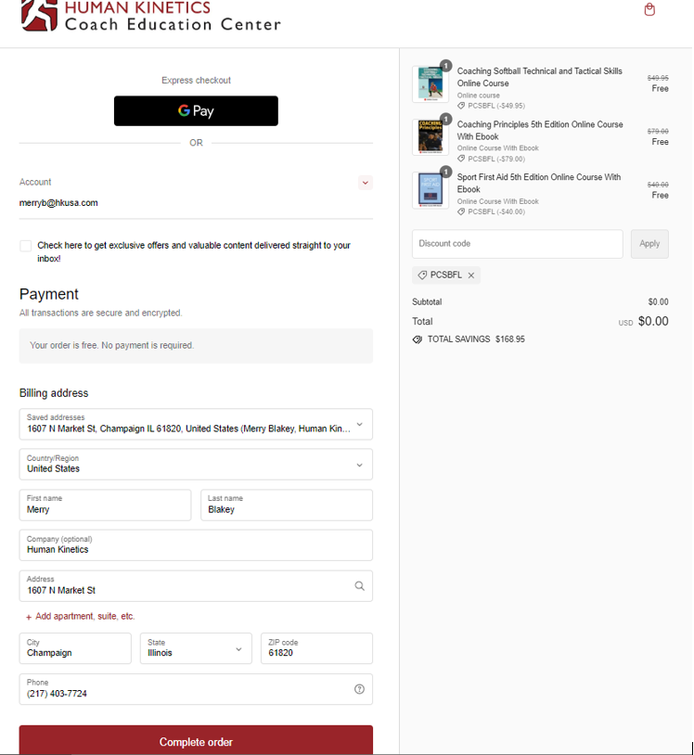

- Order confirmation screen
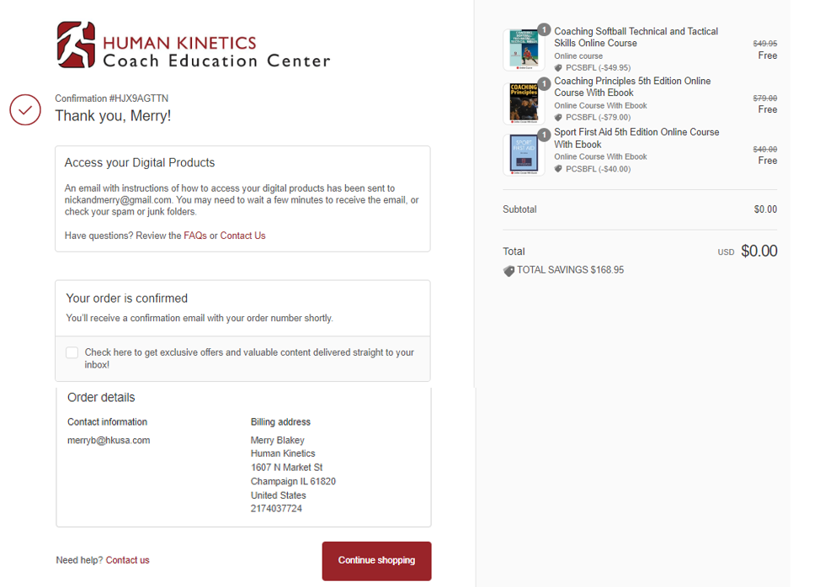

- Order Confirmation Email and Access Instructions Email
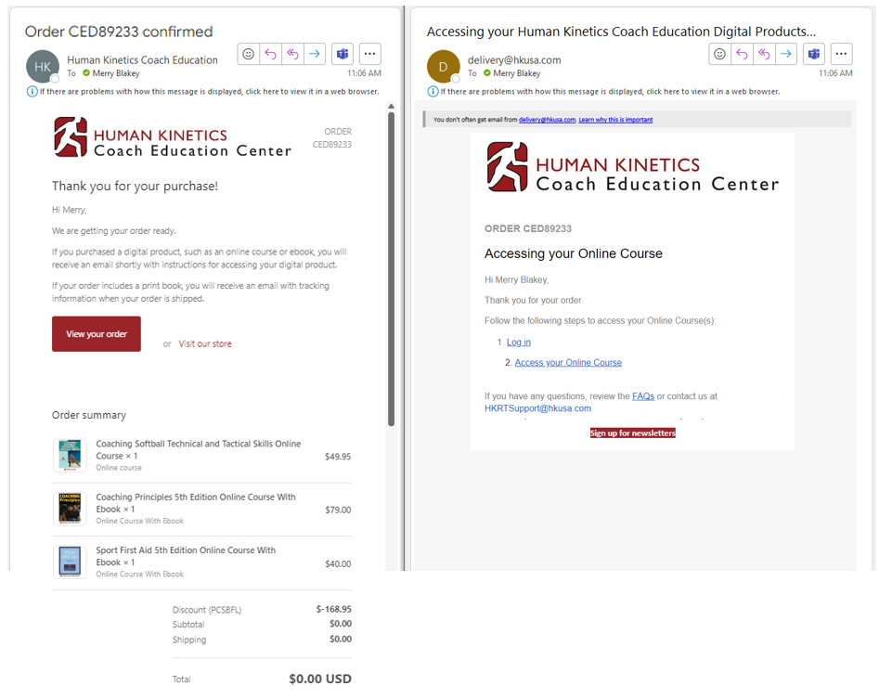

- View when clicking Access your Online Course or returning to https://coacheducation.humankinetics.com/pages/online-courses.
